Forest Lawn & Jack James High School
Forest Lawn High School
1304 44 St SE Calgary, AB T2A 1M8

CAREER RESOURCE FAIR
OVER 40 EXHIBITORS
- Post-Secondary Institutions
- Employers from various sectors
- RCMP, Calgary Fire Department, Canadian Armed Forces
- Calgary Flames Organization
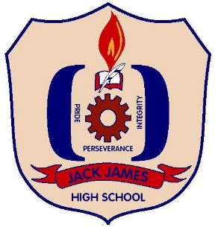
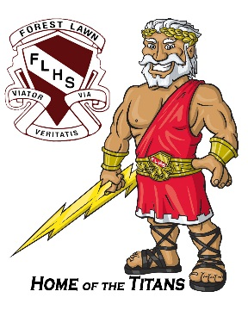

CAREER RESOURCE FAIR

Thursday May 3rd, 2018
10am – 12pm
Main Gym, Forest Lawn High School (1304 44th Street S.E., Calgary)

Contact: Leslie-Anne McKenzie (403-272-6665 ext. 2367)

Please contact Leslie-Anne McKenzie (403-272-6665 ext. 2367) for more information

